8th Grade Science
Standard 8.5A (readiness) | 3.0 Items
Describe the structure of atoms, including the masses, electrical charges, and locations, of protons and neutrons in the nucleus and electrons in the electron cloud. | Option 1:  On the provided diagram label the following:  - Subatomic particles: protons, neutrons, and electrons  - The locations of the nucleus and the electron cloud.  - Identify the charge of the particles: positive, negative, or neutral.  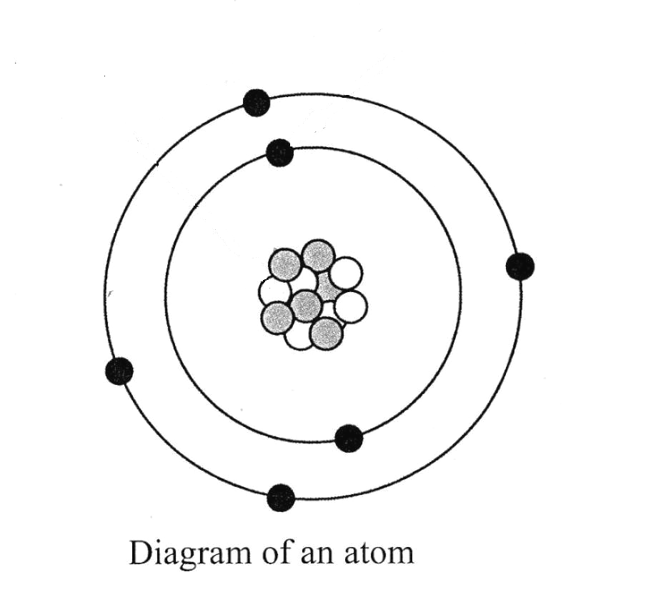  D. What is the mass of the atom?  Option 2:  *Warm up to Science - Region 4*  Place a x in the appropriate column to identify the characteristics of a proton, neutron, and an electron. Some may have more than one answer.  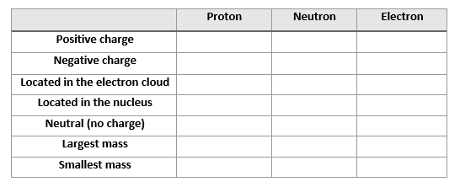
 | 2.0 Items
- What is the mass number of an oxygen atom with 10 neutrons, 8 protons, and 8 electrons?
- 2
- 10
- 18
- 26

- An atom of a certain element has 47 protons, 47 electrons and a mass of 108. How many neutrons is in this atom?
- 47
- 61
- 108
- 155

- What type of particles are found in the atom’s nucleus?
A. Positively charged particles and negatively charged particles.
B. Negatively charged particles only.
C. Neutral particles and positively charged particles.
D. Positively charged particles only.

Sirius Grade 8 Science STAAR Review and Prep WorkText
- A model of an atom is shown below.
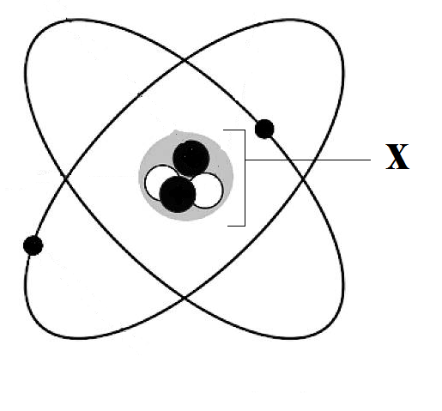
Which best describes the particle that make up the part labeled x in the model?
- They all have no charge.
- They all have a positive charge.
- Some have a positive charge and some have no charge.
- Some have a positive charge and some have a negative charge.

- Which statement best describes a proton?
- Its mass is similar to that of an electron, but it has a positive charge.
- Its mass is similar to that of a neutron, but it has no charge.
- Its mass is similar to that of a neutron, but it has a positive charge.
- Its mass is much smaller than that of a neutron, but it has a negative charge.

- A neutral atom has 12 electrons. How many protons does it have?
- 0
- 6
- 12
- 24

7. The chart below shows the number of each kind of subatomic particle in an atom.
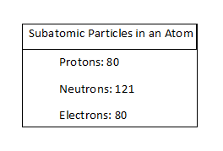
Which number describes the charge of this atom’s nucleus?
- -80
- -121
- +80
- +201

8. Which describes both electrons and protons?
- Particles of the same mass
- Particles found in the nucleus
- Particles that have an electrical charge
- Particles found in the electron cloud

9. A atom is made up of 29 protons and a mass of 64. How many neutrons does the atom have?
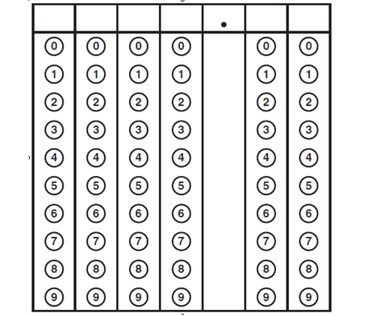

10. Which statement about the masses of subatomic particles is true?
- Electrons and neutrons have similar masses.
- Neutrons and protons have similar masses.
- Electrons, protons, and neutrons all have similar masses.
- Electrons, protons, and neutrons all have very different masses.

11. The diagram below shows a model of an atom’s nucleus.
What s the charge of this atom’s nucleus?
- +8
- 0
- -8
- +16

12. A student organized data describing the particles that make up atoms in the table below.
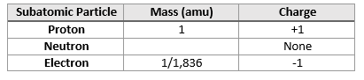
Which value should the student write in the empty box?
- 0
- 1
- 2
- 1/1,836

Like one in Mastering the TEKS
13. According to modern atomic theory, which describes a neutral atom of sodium (Na) with an atomic number of 11 and a relative mass of 23?
- 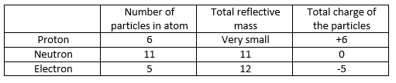
- 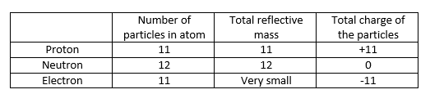
- 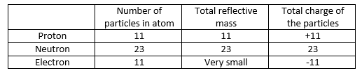
- 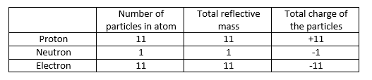

14. Determine the difference in the amount of neutrons between Chlorine (Cl) and Carbon (C)?

15. Where is most of the volume (space) of an atom?
- Nucleus
- Neutrons
- Protons
- Electron cloud

8th Grade Science
Standard 8.5B (readiness) | 3.0 Items
Identify that protons determine an element's identity and valence electrons determine its chemical properties, including reactivity. | 1.The atom of a certain element each contain 17 protons and 7 valence electrons.  A. Which statement correctly identifies this element?  - The element is Chlorine.  - The element is Bromine.  - The element is Selenium.  - The element is Nitrogen.  B. Which statement correctly identifies this element?  - The element is stable.  - The element is highly reactive.  - The element is not very reactive.  2. An atom that contains 5 protons, 6 neutrons and 5 electrons.  - Draw a Bohr model of the atom  - Label each type of subatomic particles, nucleus, the electron cloud, and valence electrons.  - Use the Periodic Table to determine the element represented by this model.  - Boron  - Carbon  - Sodium  - Magnesium  - Determine the atom's reactivity.  - Stable  - Somewhat Reactive  - Very reactive.
 | 2.0 Items
Sirius Grade 8 Science STAAR Review Prep WorkText
1. Two pure substances consist of atoms that all have the same number of protons. However, the atoms of each substance have different number of valence electrons. What must be true of these two substances?
- They react similarly.
- They are the same element.
- The atoms have the same charge.
- Their nuclei have different charges.

2. Magnesium (Mg) has an atomic number of 12 and a group number of 2A. Therefore, the number of valence electrons in a magnesium atom is -
- 2
- 8
- 12
- 10

3. These models show an atom for each of two different elements.
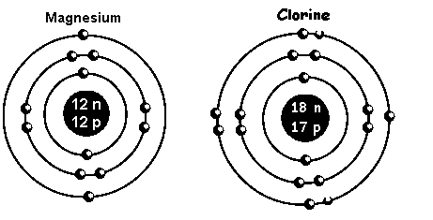

Which difference between the atoms makes them different elements?
- Magnesium atom has 12 protons; chlorine atom has 18 protons.
- Magnesium atom has 12 neutrons; chlorine atom has 18 neutrons.
- Magnesium atom has 2 energy levels; chlorine atom has 3 energy levels.
- Magnesium atom has 2 valence electrons; chlorine atom has 7 valence electrons

Sirius Grade 8 Science STAAR Review Prep WorkText
4. Atom X has an atomic number of 5. Atom Y has an atomic number of 35. All of these statements about atoms X and Y are correct except -
- Atom X has 3 valence electrons
- Atom X has the same symbol as atom Y
- Atom Y has 7 valence electrons
- Atom Y is more reactive than atom X

5. Which number determines the element an atom represents?
- Atomic number
- Group number
- Neutron number
- Period number

6. Which number determines the reactivity of an atom?
- Atomic number
- Group number
- Neutron number
- Period number

7. How many valence electrons does this atom contain?
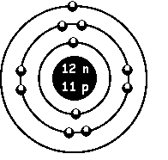
- 12
- 2
- 1
- 35

8. Which element is the most reactive?
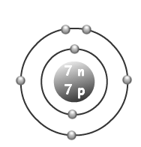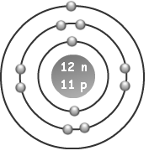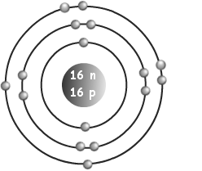
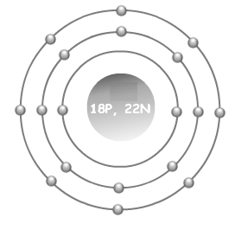

8th Grade Science
Standard 8.5C (readi | 3.0 Items
Interpret the arrangement of the periodic table, including groups and periods, to explain how properties are used to classify elements. | Image from released STAAR, question is different  - A student is studying the ways different elements are similar to one another. Diagrams of atoms from four different elements are shown below.  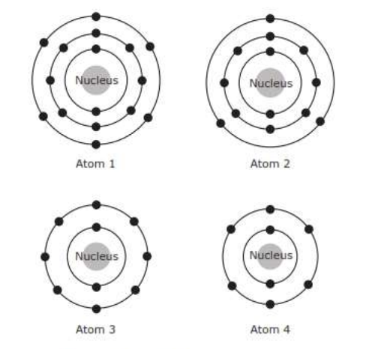  - Which atoms are in the same period on the periodic table?  - Atom 1 and 2  - Atom 1 and 3  - Atom 3 and 2  - Atom 4 and 1  B. Which atoms are in the same group on the periodic table?  - Atom 1 and 2  - Atom 1 and 3  - Atom 3 and 2  - Atom 4 and 1  C. Which atoms have similar chemical properties?  - Atom 1 and 2  - Atom 1 and 3  - Atom 3 and 2  - Atom 4 and 1  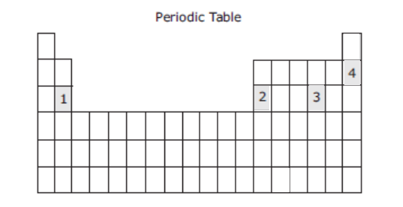  D. Which atoms are identified in the correct location of the periodic table?  - Atom 1  - Atom 2  - Atom 4  - Atom 1 & Atom 4  2.  A. Draw two atoms that are in the same period.  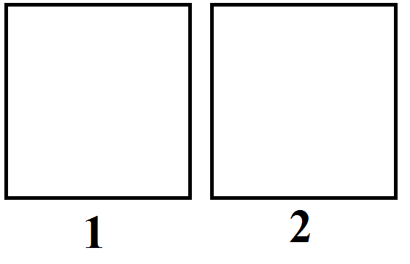  B. Label the period and group number of the two atoms.  1: Period___________________ Group _______________  2. Period___________________ Group _______________  C. List the reactivity of the two atoms. Stable, somewhat reactive, very reactive)  1. ___________________________________  2. ___________________________________  D. Write the number where the atom appears on the Periodic Table.  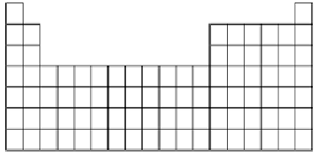
 | 2.0 Items
Sirius Grade 8 Science STAAR Review Prep WorkText
- What do all the elements in Group 8A of the periodic table have in common?
  - They are all solids with a high density.
  - THey all have 18 protons and 18 electrons.
  - They all have a complete outer energy level.
  - They all react quickly with Group 1A elements.
Sirius Grade 8 Science STAAR Review Prep WorkText
2. A representation of the periodic table is below. 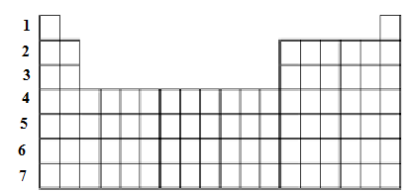
The number to the left of each row represents the number of -
- Protons in atoms of the first element.
- Compounds that each element will form
- Energy levels in the atoms of each element
- Valence electrons in the atoms of each element.

3. A model of a neutral atom of a certain element is shown below.
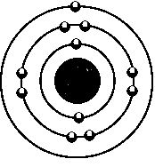
- In the periodic table, this element would be in Group -
  - 1
  - 3
  - 5
  - 11

- In the periodic table, this element would be in Period -
  - 1
  - 3
  - 5
  - 11

4. Find Potassium (K) on the Periodic Table. What group is it in?
- 1
- 2
- 4
- 5

5. How many energy levels would Calcium (Ca)have?
- 1
- 2
- 3
- 4

Sirius Grade 8 Science STAAR Review Prep WorkText - Modified from
6. Which group on the Periodic Table do not react readily?
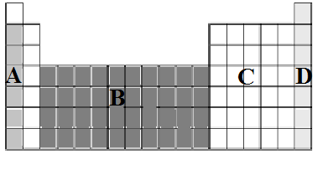
- Grouping A
- Grouping B
- Grouping C
- Grouping D

7. Which group has 1 valence electron and is very reactive?
a. Grouping A
B. Grouping B
C. Grouping C
D. Grouping D

Mastering the TEKS
8. Referring to period 3 on the periodic table. Why are these elements organized together in a row with no elements in groups 3-12?
- Elements are listed according to increasing atomic mass. Groups 3-12 are left blank because there is a large gap between the masses of Magnesium and Aluminum.
- Elements are listed according to increasing atomic mass. Groups 3-12 are left blank because stating with Aluminum each element has properties more similar to the elements below it than elements in groups 3-12.
- Elements are listed according to increasing atomic number. Groups 3-12 are left blank because these groups are reserved for elements that are metalloids.
- Elements are listed according to increasing atomic number. Groups 3-12 are left blank because starting with Aluminum each element has properties more similar to the elements below it than the elements in groups 3-12.

9. The periodic table is organized into groups and periods of elements. The characteristics of a certain group of elements are listed below.
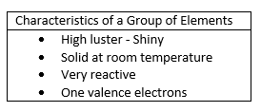
Which of these elements is in this group?
- Calcium
- Bromine
- Aluminum
- Cesium

